Neural Networks



We have 3 types of layers in a neural network,

1. Input layer
2. Hidden layer
3. Output layer

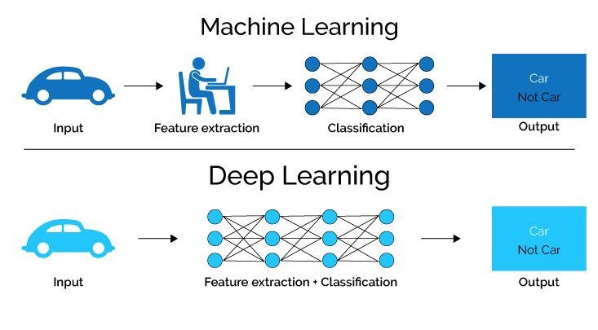

In deep learning, both Feature extraction as well as classification both is done by the machine itself whereas in machine learning, feature extraction is done by us and not by the machine.

Why do we need non-linearity (non-linear activation functions) in neural networks?  
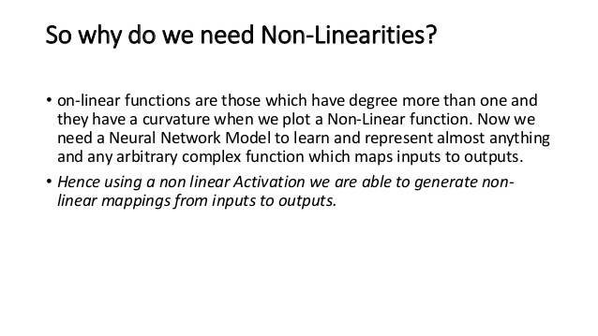

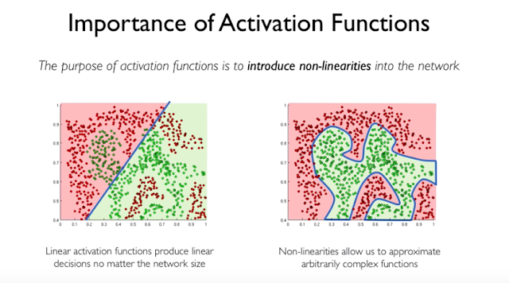

Deep learning problems are non-linear by nature and we can’t do predictions using a linear function.

There are 3 types of Neural Network

1. Artificial Neural Network (ANN).

2. Convolutional Neural Network (CNN).

3. Recurrent Neural Network (RNN).

Artificial Neural Networks (ANN)

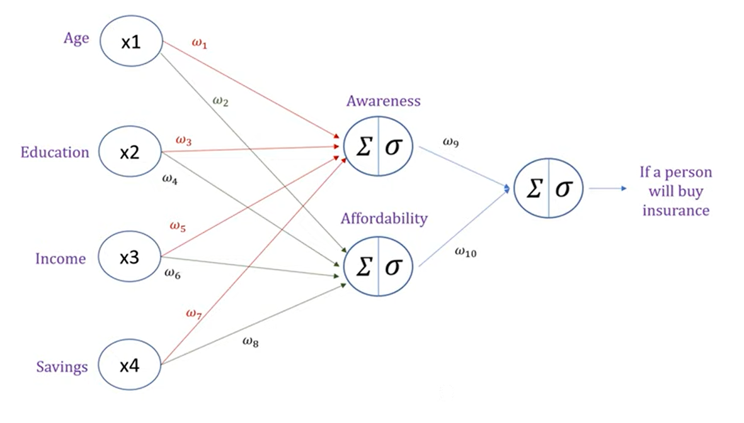

In AAN, we have 2 types of processes happening in our neural network,

1. Forward propagation
2. Backward propagation

Forward Propagation

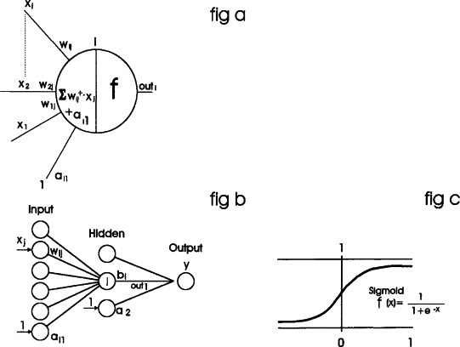

In forward propagation, every neuron does 2 steps which can be seen from fig 1 of above image,

* Calculates Z = (wi)*x + b // where wi = ith slope or weight
* Calculates sigmoid of resultant ‘Z’ sigmoid(Z) and passes the result to the next neuron of next layer with other weights and continues the same procedure till the output layer.

When the output (prediction y’) is made, an error is calculated using the cost function and now weights are adjusted(updated) and prediction value is calculated again by backpropagation to get predicted value with minimal error possible. The backpropagation will adjust(update) the weights in such a way that error is minimized.



Backpropagation





In Backpropagation process, when the output or a prediction is made using forward propagation, we go back from output layer till the first layer and update the weights. We do this backpropagation and forward propagation again and again, and stops when we get minimal error or best result. The weights(slopes) of each layer are updated using chain rule.

The Chain Rule

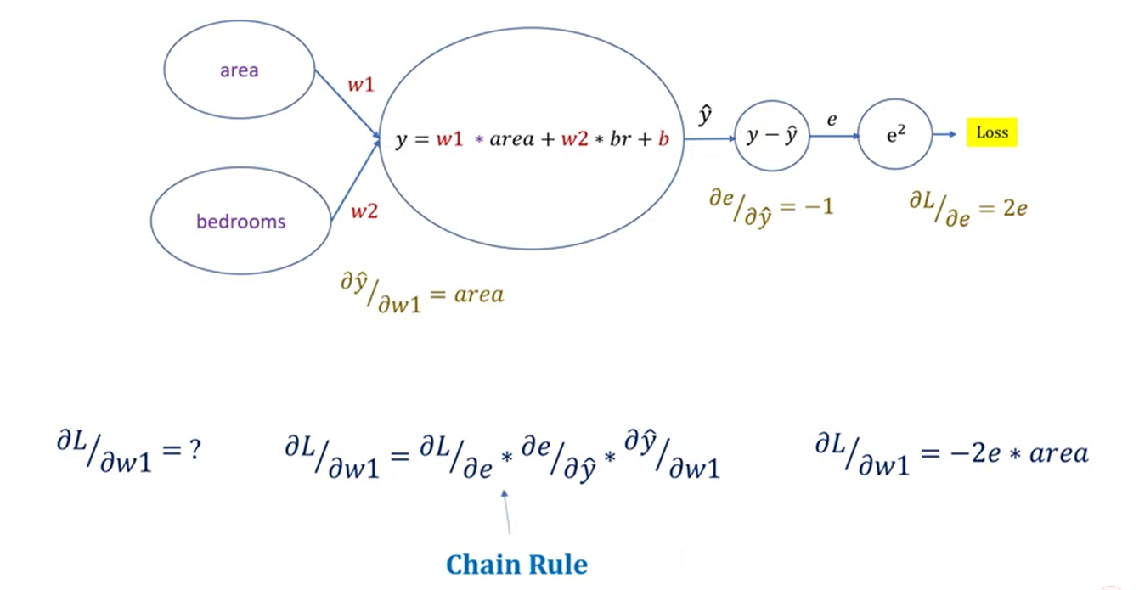

Note: The derivative here is partial derivative which means all other variables will be treated as constant except for the one with whom the derivative is being taken.

Slope 🡪 weights (we are actually updating slopes).

Here we calculated the partial derivative of Loss w.r.t partial derivative of weight#1 which will include all the slopes (partial derivatives) of the layers in between them. Similarly, if we want to find the slope or weight of any layers, then we will have to include partial derivatives (slopes) of the layers in between them.

Example#1,

Partial derivative of Loss / partial derivative of w2 = dL/de * de/dy * dy/dw2.

Weights or slopes are then updated using following equation,

W(old) = w(new) – learning rate * partial derivative which was calculated using the chain rule. (Gradient descent)

Example#2,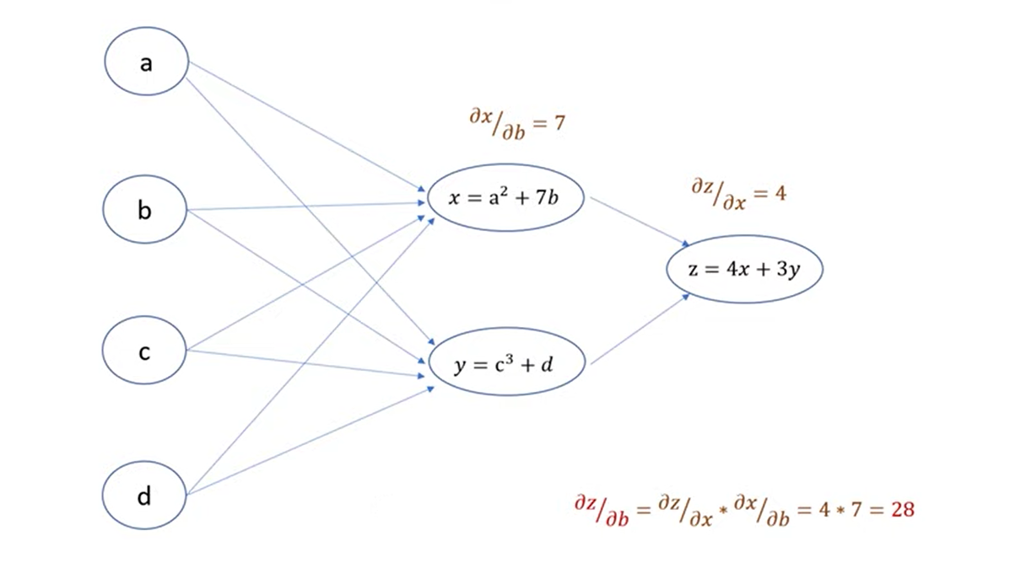The activation function of ANN can be sigmoid, softmax, relu, leaky relu, tanh etc.

Convolutional Neural Network (CNN)

**Convolutional Neural Networks**, or CNNs, were designed to map image data to an output variable. They have proven so effective that they are the go-to method for any type of prediction problem involving image data as an input.

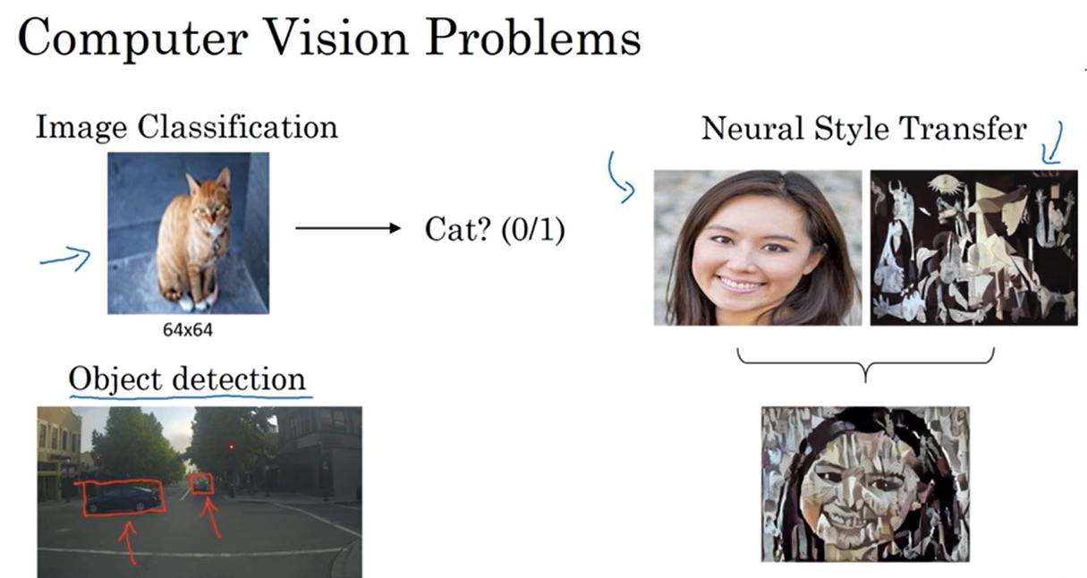

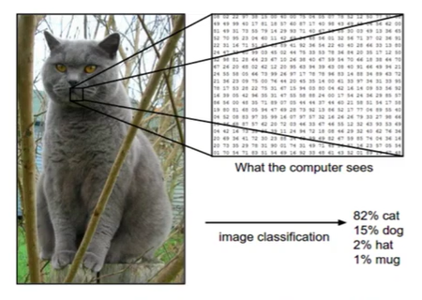

Everything we did in Artificial Neural Network (ANN) is included in CNN in its fully connected layer or dense layer. However, before going to the dense layer or the fully connected layer it has to come through many convolutional cycles or convolutional layers. The output of these convolutional layers is flattened (converted to 1D array) and are passed to the dense layer and then the remaining process is same as of Artificial Neural Network (ANN).



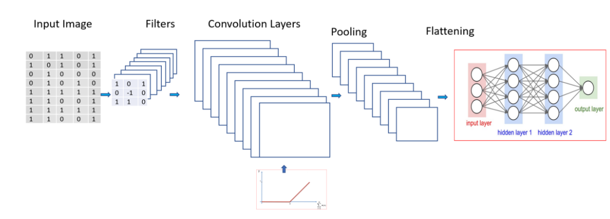

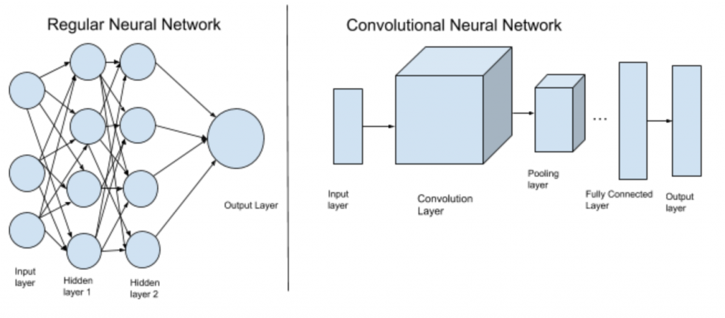

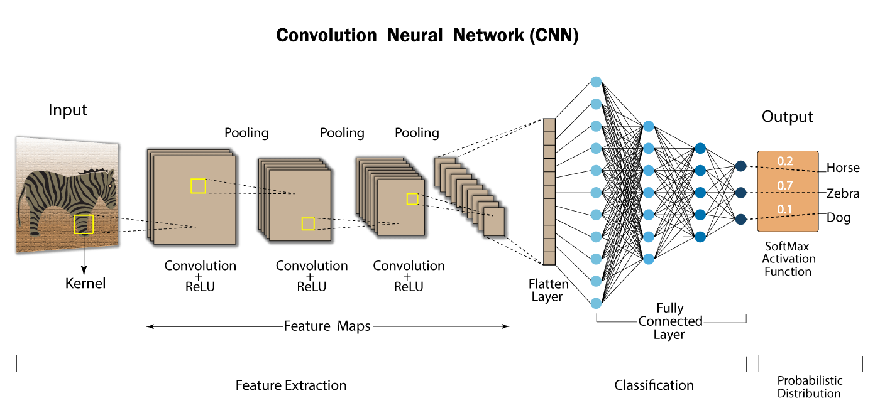

Feature Extraction is done by the convolution layers and after that the classification is done by the dense layer or the fully connected layer.



Convolution Layer (Feature Extraction Layer)

Each convolution layer in a CNN is used to extract a feature or is used to work on a feature. Suppose the first convolution layer finds the vertical edges, the second one finds the horizontal edges of object in the input image, the third one works on eyes, fourth on nose, fifth on hair and so on and after working on these features one convolutional layer merges all these features to construct the object and may pass the constructed object to the dense layer or the fully connected layer in the form of a 1D array (flattened array) and then that dense layer will classify that object.

A convolution layer includes following sub layers in it,

**Image (Input Layer) 🡪 Feature Extractor/Filter/Kernel 🡪 Feature Map 🡪 Bias 🡪 Activation function (Relu or Leaky Relu) 🡪 Convolutional Logic 🡪 Avg/Max Pooling(optional) 🡪 Back to feature extractor/filter/kernel.**

Again, the filter is applied to the resultant feature map of first output.

This cycle from Pooling **🡪**Feature Extractor/Filter/Kernel is continued and backpropagation is done until we find appropriate weights for our feature the machine will keep learning or back propagating until it finds relevant weights for the feature on which it was working.

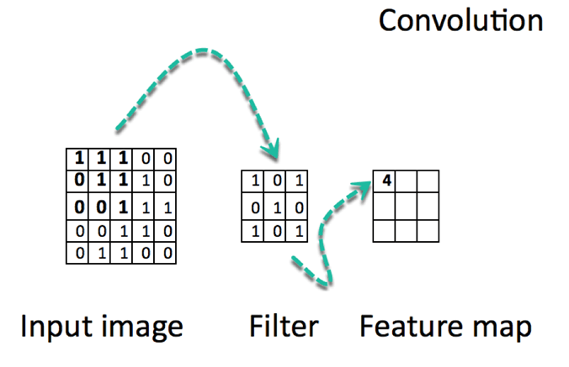

The dimensions of feature map can be calculated from the following formula,

Dimensions = [(image size - filter size + 2*padding) / total strides (filtering steps)] + 1.

**Strides**

Strides is the total gap or the skipped rows and columns during the movement of filter inside the image. In the image below, the value of stride is 1 because 1 row and 1 column are skipped during movement of the filter.



A CNN can have either a gray scale image of 1 channel or an RGB image having 3 channels in it (dimensions R, G, and B each of these 3 dimensions are equivalent to 1 gray scale image channel).

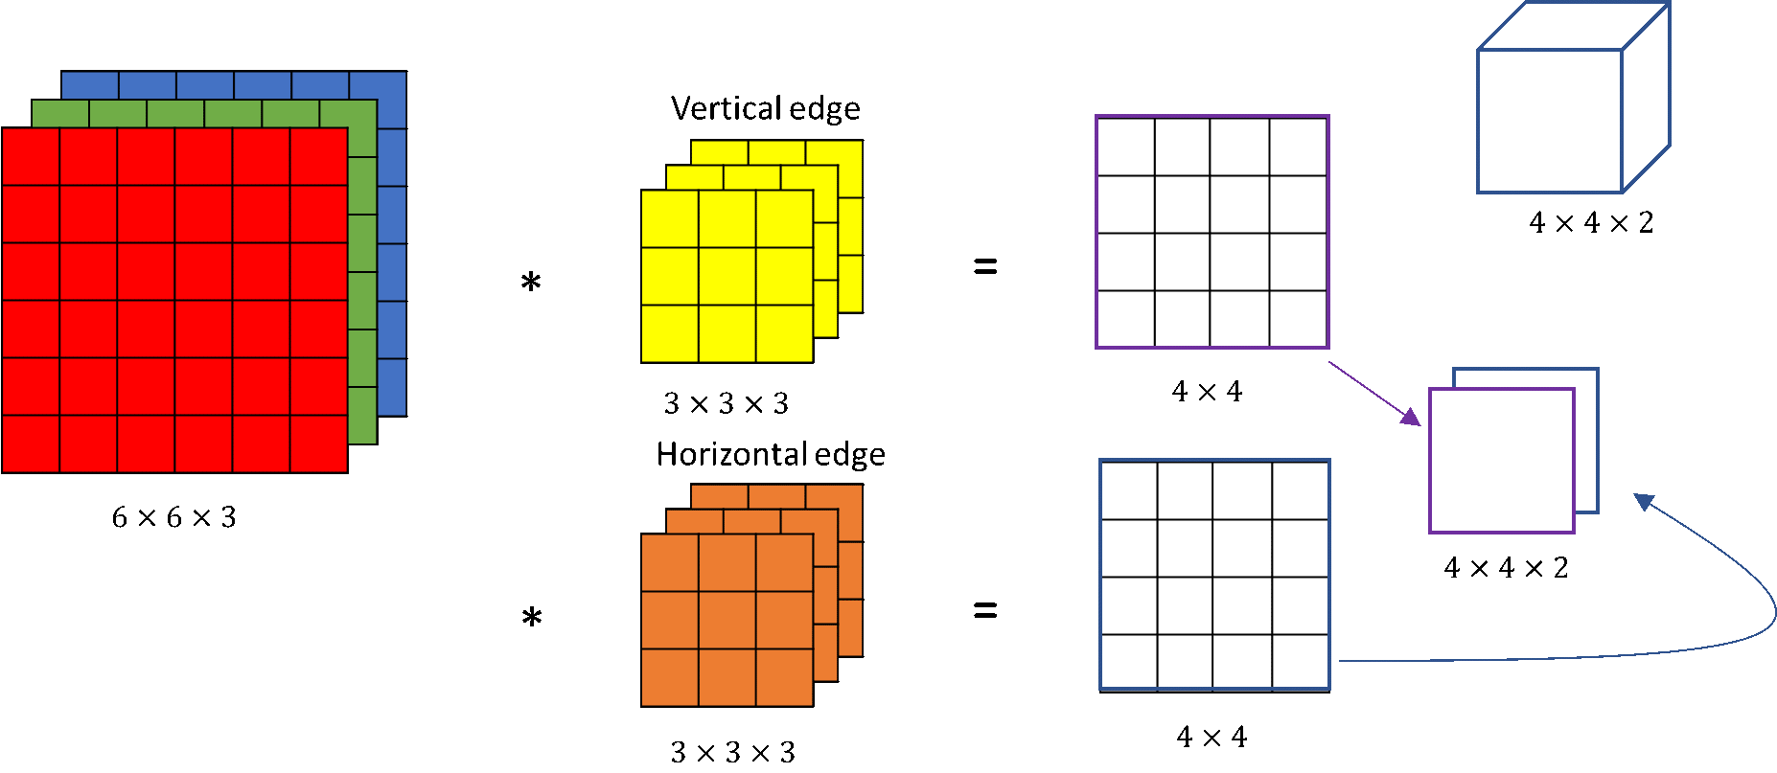

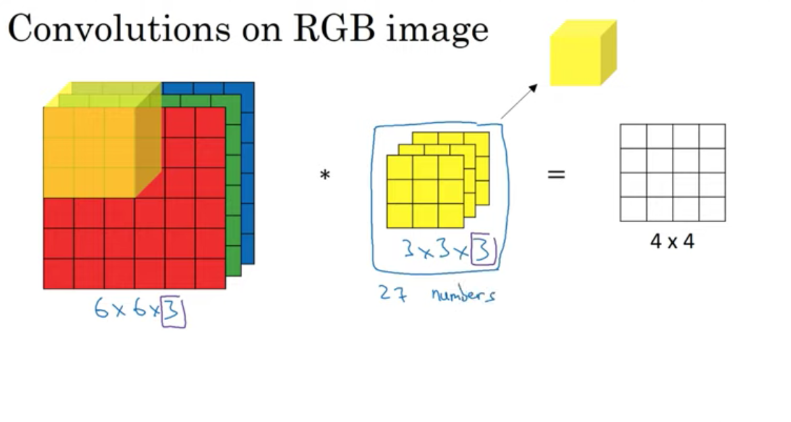



Feature map elements are the sum of the direct multiplication of image elements with the filter elements.

Example,

In the above image, the value 4 comes by multiplying and adding following,

1*1 + 1*0 + 1*1

0*0 + 1*1 + 1*0

0*1 + 0*0 + 1*1

=

1+1+1+1 = 4

This calculation of feature map can also be seen from the following image,







Once the feature map is calculated, a bias is added and activation function like Relu, leaky relu is applied in convolutional layers. We do not use sigmoid and softmax activation functions in convolutional neural network layers because they lead to vanishing gradient problem and exploding gradient problem. After applying activation function, we define a convolutional logic and then do pooling and then repeats the cycle from the filter and now our input for next iteration is our previous feature map.

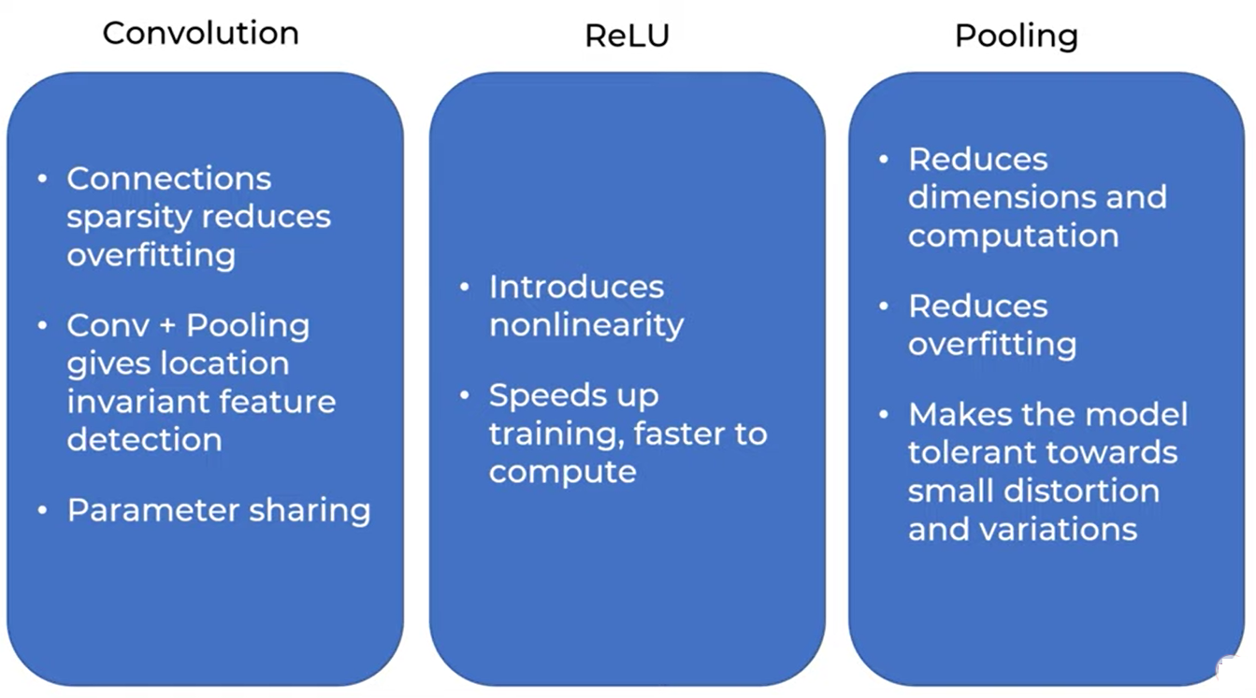

Padding

Padding is also added in original image in order to get feature map of size similar to the input image.

 

There are various types of padding but mostly we use 0 padding in which we initialize the rows and columns as 0. In other padding types we use neighbor values also.

Pooling

Pooling is a process through which we reduce the computation as well as the dimensions of the existing image and works only on important weights. The dimensions of the pooling matrix can be calculated using following formula,

Dimensions = [(image size - filter size + 2*padding) / total strides (filtering steps)] + 1.

There are basically 2 types of pooling.

1. Max pooling (max value is selected)
2. Mean pooling (Average of values is selected)

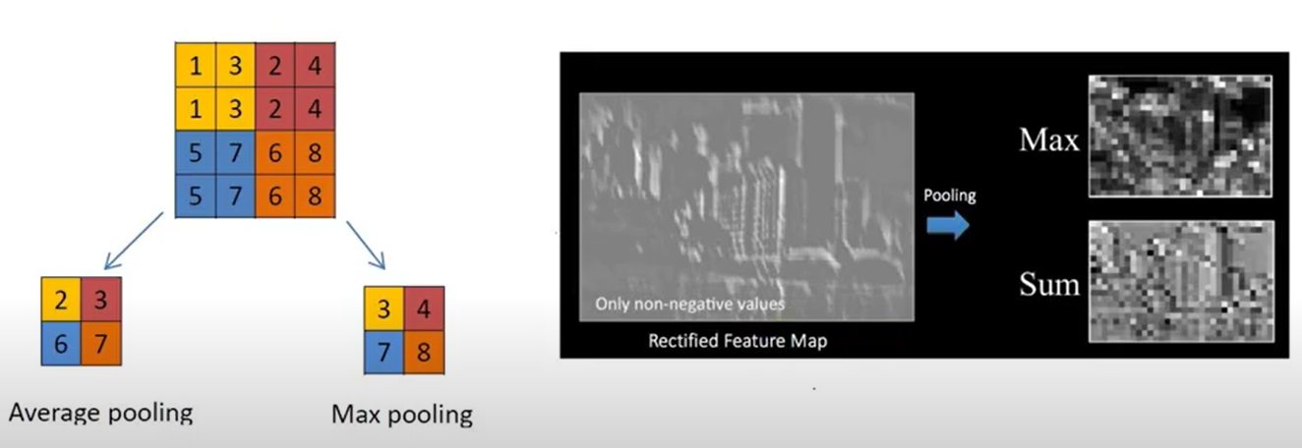





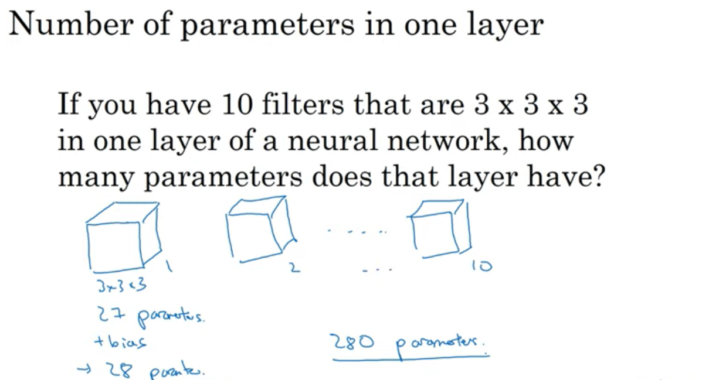

The Vanishing Gradient Problem

The Exploding Gradient Problem

Data Augmentation

